There was a science fiction movie titled Doom released in 2005, loosely based on the popular video game franchise. The movie was theatrically released in 2005 but reached home media formats like DVD and Blu-ray in 2006.

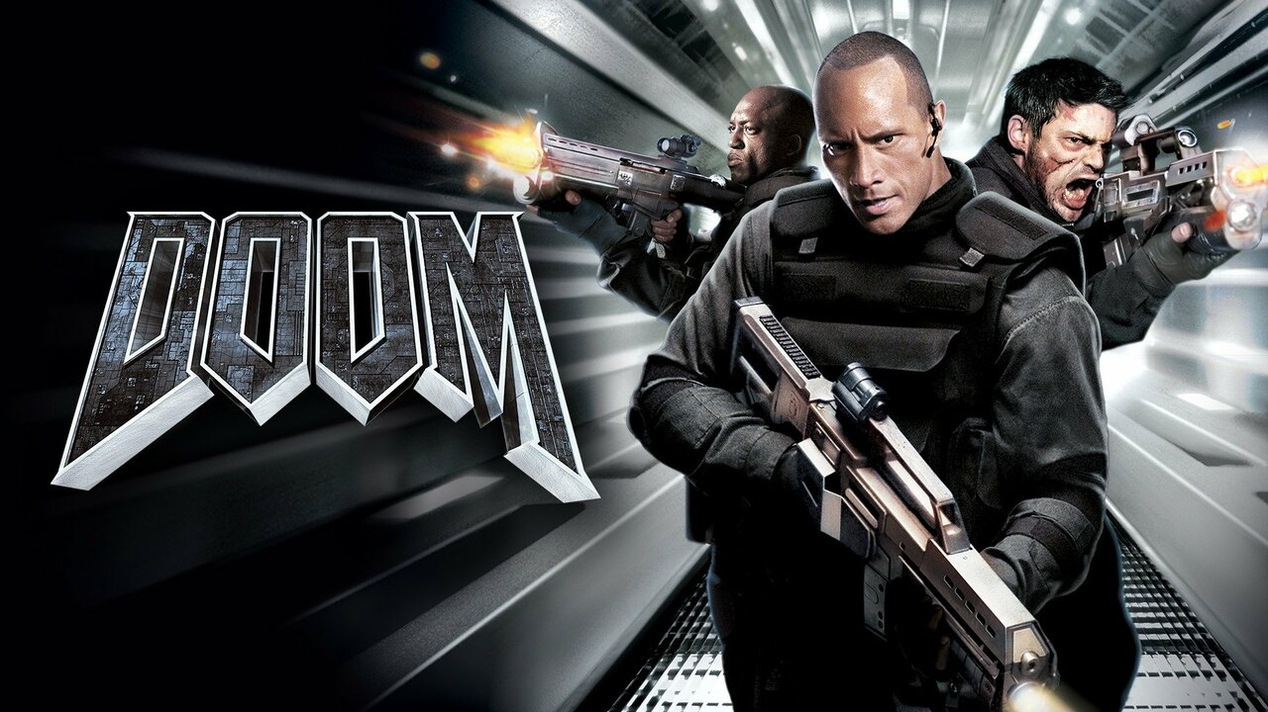

The Doom video game franchise itself has had many releases over the years, but there wasn't a specific Doom game released in 2006. The latest Doom game before 2006 was Doom 3, released in 2004. The next major installment in the franchise was a 2016 reboot simply titled Doom.